 Polynomial and Rational Functions Name _________________________

A2RCC U8D2 Homework

1. Consider the cubic whose equation is $y=x^{3}-x^{2}-12x$.

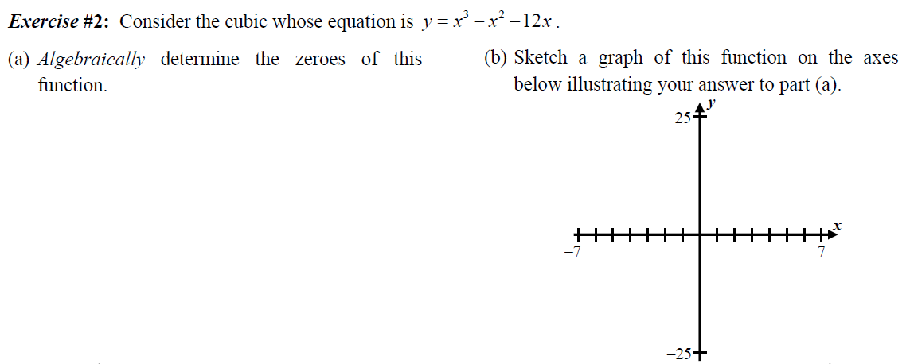



1. The largest root of $x^{3}-9x^{2}+12x+22=0$ falls between what two consecutive integers?

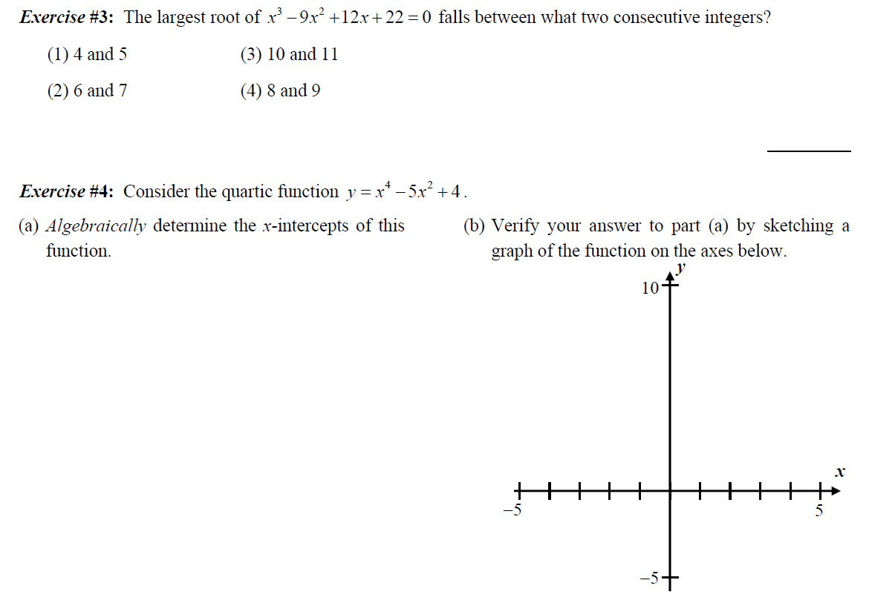

1. Consider the quartic function $y=x^{4}-5x^{2}+4=0$.





1. Consider the quartic whose equation is $y=x^{4}+3x^{3}-35x^{2}-39x+70=0$

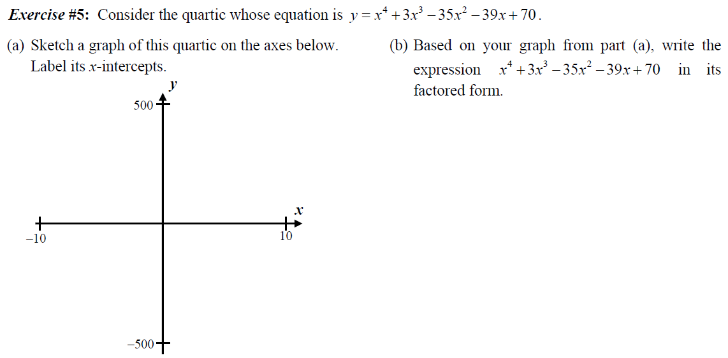

1. **Factor** the following polynomials.
2.  b) 
3. **Solve** algebraically.
4.  b) 